**Robotic Leader-Follower System**

*Created by Team Robot Follower:*

Christian Nickolaou, Alex Alwardt, Anton Cataldo, Scott Dudley, Eric Ramocki, and Sean Ramocki

*Sponsored by U.S. Army RDECOM-TARDEC at Detroit Arsenal:*

Ryan Wood, Dominic Dabish, Gregory Czerniak, Sahar Hassan, James Mason, and Matthew Stein

**Table of Contents:**

1. **Project Vision pp. 00**

1.1. Background pp. 00

1.2. Socio-economic Impact, Business Objectives, and Gap Analysis pp. 00

1.3. Security and Ethical Concerns pp. 00

1.4. Glossary of Key Terms pp. 00

1. **Project Planning and Management pp. 00**

2.1. Term Information pp. 00

2.2. Tools and Technology pp. 00

2.3. Best Standards and Practices pp. 00

2.4. Project Plan pp. 00

2.5. Risk Management pp. 00

1. **System Requirement Analysis pp. 00**

3.1. Functional Requirements pp. 00

3.2. Non-functional Requirements pp. 00

3.3. On-Screen Appearance of Landing and Other Pages Requirements pp. 00

3.4. Wireframe Designs pp. 00

1. **Functional Requirements Specification pp. 00**

4.1. Stakeholders pp. 00

4.2. Use Case Diagram (Actors and Goals) pp. 00

4.3. Users Stories, Scenarios and Use Cases pp. 00

4.4. System Sequence / Activity Diagrams pp. 00

1. **User Interface Specifications pp. 00**

5.1. Preliminary Design pp. 00

5.2. User Effort Estimation pp. 00

1. **Static Design pp. 00**

6.1. Class Model pp. 00

6.2. System Operation Contracts pp. 00

6.3. Mathematical Model pp. 00

6.4. Entity Relation pp. 00

1. **Dynamic Design pp. 00**

7.1. Sequence Diagrams pp. 00

7.2. Interface Specification pp. 00

7.3. State Diagrams pp. 00

1. **System Architecture and System Design pp. 00**

8.1. Subsystems / Component / Design Pattern Identification pp. 00

8.2. Mapping Subsystems to Hardware (Deployment Diagram) pp. 00

8.3. Persistent Data Storage pp. 00

8.4. Network Protocol pp. 00

8.5. Global Control Flow pp. 00

8.6. Hardware Requirement pp. 00

1. **Algorithms and Data Structures pp. 00**

9.1. Algorithms pp. 00

9.2. Data Structures pp. 00

1. **User Interface Design and Implementation pp. 00**

10.1. User Interface Design pp. 00

10.2. User Interface Implementation pp. 00

1. **Testing pp. 00**

11.1. Unit Test Architecture and Strategy/Framework pp. 00

11.2. Unit Test Definition / Test Data Selection pp. 00

11.3. System Test Specification pp. 00

11.4. Test Reports per Spring pp. 00

1. **References pp. 00**

**1. Project Vision**

**1.1. Background**

On the modern battlefield, the ability to deploy troops on the ground in a fast and efficient manner is important to ensuring your side has the tactical advantage. One critical step in deploying troops is using vehicles to deliver troops to the correct destination. Today’s technology allows for the use of computer vision and robotics to control different vehicles. These pilotless systems must be able to drive to the correct location without hitting each other, as well as handle navigation issues that may arise with loss of sight.

**1.2. Socio-economic Impact, Business Objectives, and Gap Analysis**

Every vehicle needs at least one pilot controlling the vehicle to make sure it is on the right course and nothing goes wrong. What we want to do is reduce the need for pilots in case there is a mission where there are more vehicles than pilots. By programming a vehicle to autonomously follow another vehicle, there will be less need for pilots. The use of a system like this will save a lot of time and money, because there will be less need for soldiers who know how to operate specific vehicles and training for soldiers without that knowledge. With a system of one leader vehicle and one follower vehicle, there would only need to be a pilot of the leader vehicle, cutting the need for pilots in half. Since the autonomous vehicles can also follow each other, so long as the front-most follower vehicle is following the leader vehicle, the amount of pilots can be specified to whatever is needed for the mission. This can be useful if there is a shortage of pilots. Additionally, the risks of pilot error are significantly reduced because the autonomous vehicles will follow their programming. There will be protocols for just about every scenario, so the soldiers inside the follower vehicles will only need to have minimal knowledge of the vehicle. Therefore, a leader-follower vehicle system will cut the cost of pilots and pilot training as intended.

**1.3. Security and Ethical Concerns**

Since the autonomous vehicles will be self-piloted, it is important that the programming does not get compromised. If a hacker is able to get control of a vehicle, then that puts everyone inside the vehicle at risk. That is why it’s important to make sure the programming is protected by encryption to add layers of security so that the vehicles are protected against cyber attacks. It is also important that there is a method of decryption so that a soldier may debug or repair the vehicle’s programming if there is something wrong with the code.

**1.4. Glossary of Key Terms**

Pilot - The individual who utilizes the App Controller to navigate the Leader Vehicle.

App Controller - The client-side application the Pilot uses to control the Leader Vehicle.

Leader Vehicle - The robot that the Pilot is directly controlling with the App Controller.

Follower Vehicle - The robot that autonomously follows the Leader Vehicle using its Camera.

Camera - The sensor attached to a Follower Vehicle that allows it to autonomously follow a Leader Vehicle by sensing the Leader’s location.

Leading Object - The object on the Leader Vehicle that the Follower Vehicle’s Camera senses to follow using its orientation.

Obstruction Object - Any object that hinders the path of a Follower Vehicle.

Learning Module - An autonomous module that the Follower Vehicle uses to learn where to follow the Leader Vehicle.

Obstruction Object - Any object that hinders the path of a Follower Vehicle.

Line of Sight - The state when a Follower Vehicle directly views the Leader Vehicle.

Navigational Log - The data the Lead Vehicle and Follower record to determine relative position.

**2. Project Execution and Planning**

**2.1. Term Information**

Our team will build a robotic vehicle system consisting of a leader vehicle and one or more follower vehicles. There must be at least two vehicles in this system (one to lead and one to follow). These vehicles must not collide with each other. The project should also consider incorporating a system that handles the follower vehicle losing line of sight or maneuvering around an obstruction object, the ability to make any vehicle the leader vehicle, and communication of navigational data between the robots.

**2.2. Tools and Technology**

The robot that our team is using as a vehicle is Sunfounder’s PiCar-V, which is essentially a robot hardware kit made to be built around a Raspberry Pi. The Raspberry Pi is used to control the hardware to move the robot and control a camera. Once the kit is built, there will be four wheels, three servos, two motors, and a camera all attached to the Raspberry Pi. The motors will control the motion of the wheels. One servo will control the turning direction of the wheels and the other two servos will control the position of the camera. The camera connects to the Raspberry Pi via USB to directly provide its video feed. The PiCar-V has its own implementation for controlling the robot but also allows for open source coding, which is how we will implement our system around the PiCar-V kit. Our system will consist of two PiCar-Vs, one as a leader and one as a follower, so we will have two kits and two Raspberry Pis to work with. We will also have a desktop application, with remote controller support, that the pilot will use to control the robots and our own router to make sure the communication between the robots and the application is on a closed network. The Raspberry Pis will run Python code executed in Linux OS, specifically Raspian. The desktop application will run Visual C# code on Windows OS. The desktop client will communicate with the robot servers through a gRPC protocol. Additionally, we will use OpenCV for the camera on the follower vehicle to follow the leading vehicle by reading the orientation of its leading object, which we will use QR codes for.

**2.3. Best Standards and Practices**

We decided to use the Scrum approach for managing our project. This will allow us to plan our progress through Sprints and manage our progress through team meetings. Each Sprint was roughly 2 weeks, where our team focused to complete specific goals by the end of the Sprint. To split the work as evenly as possible, we decided to split into team roles as such:

Christian Nickolaou - Project Lead / Vehicle Systems & Image Recognition Developer

Alex Alwardt - Network & Video Streaming Developer

Anton Cataldo - Documentation / Vehicle Systems & Image Recognition Developer

Scott Dudley - Documentation / Vehicle Systems & Network Developer

Eric Ramocki - Desktop Application Developer

Sean Ramocki - Desktop Application Developer

We decided for the full team to meet twice a week to discuss progress for individual team members to achieve the team goals. These meetings also allowed the team to work together to bridge the connection between the progress of different roles.

**2.4. Project Plan**

Sprint 1: 9/6/2018 - 9/13/2018

* Project Plan
* Requirements
* Tool Chain Setup
* Project Scope Capture

Sprint 2: 9/13/2018 - 9/25/2018

* Basic Diagrams
* User Stories / Detailed Use Cases
* Hardware Research
* Start Network Messaging Protocol

Sprint 3: 9/25/2018 - 10/11/2018

* Desktop Application UI Skeleton
* Receive/Build Vehicles
* Finish Network Server
* Finish Network Client
* Registering the Vehicles

Sprint 4: 10/11/2018 - 10/23/2018

* Configuration of Motors/Servos
* Making Application Asynchronous
* Full Movement of Leader Vehicle
* Start Video Streaming
* Start Image Recognition

Sprint 5: 10/23/2018 - 11/6/2018

* Finish Video Streaming on Vehicle
* Finish Video Streaming on Application
* Direct IP Connection in Application
* Finish Desktop Application Implementation
* Finish Installing/Integrating Dependencies
* Image Recognition for Follower Vehicle

Sprint 6: 11/6/2018 - 11/27/2018

* Image Recognition between Leader and Follower Vehicles
* Collision Detection for Follower Vehicle
* Recording/Setting Distance Between Vehicles
* Camera Debugging

Sprint 7: 11/27/2018 - 12/4/2018

* Testing / Debugging
* Dry Run

Sprint 8: 12/4/2018 - 12/11/2018

* Testing / Debugging
* Final Competition

**2.5. Risk Management**

The biggest risks we had to overcome were potential problems with the hardware. The Raspberry Pis as well as the other components we connected to them are very fragile. During the assembly of one of the robots, one of the servos overheated. To prevent potential damage to other components, we halted the robot’s assembly until we got a replacement servo. We also had other problems halting assembly, including getting the hardware late and needing specific batteries to run the robots. We managed all of these issues by focusing more on the application and network protocol while waiting for the needed components to arrive. We split into different teams, which helped boost our progress per Sprint, but we also had a lot of problems getting our code to work together. It was hard to get our code to mesh together if we didn’t understand a problem with the other person’s code. Our team decided to manage this by using a Discord chatroom to discuss errors and other problems so we could try to find solutions together for these problems. This method proved to be very effective for debugging and troubleshooting our code. Additionally, when progress was halted for a certain aspect of the project, we scheduled additional meetings with the necessary team roles to fix the problems. The biggest problem we had getting our code to work together was the image recognition software and the video streaming software crashing the application because they were both trying to access the camera at the same time. This was easily solved by our communication through Discord and extra team meetings. Another risk that we had to overcome was that we needed to make sure that our dependencies for the robots all matched the same version of Python and OpenCV so that everything could work together. Another risk we had was overcoming Oakland University’s limited internet access. We ended up needing to bring our own router for the network protocol to work between the robots and desktop application. This allowed us to test our system on-site during meetings without having to worry about Oakland University’s firewall or other public connections.

**3. System Requirement Analysis**

**3.1. Functional Requirements**

1. The application shall allow the leader vehicle to move forward by remote control.
2. The application shall allow the leader vehicle to move backwards by remote control.
3. The application shall allow the leader vehicle to turn left by remote control.
4. The application shall allow the leader vehicle to turn right by remote control.
5. The application shall be able to transmit position changes to the follower vehicle.
6. The application shall allow the follower vehicle to interpret position changes into left position motion.
7. The application shall allow the follower vehicle to interpret position changes into right position motion.
8. The application shall allow the follower vehicle to interpret position changes into forward position motion.
9. The application shall allow the follower vehicle to interpret position changes into backwards position motion.
10. The application shall allow the follower vehicle to follow directly behind the leader vehicle.
11. The application shall allow a follower vehicle to follow directly behind another follower vehicle, as long as there is a leader vehicle in the front of the vehicle train.
12. The application shall prevent the follower from colliding with the leader vehicle.
13. The application shall stop motion on all out of range remote controlled vehicles.
14. The system shall only support one wireless controller.
15. The system shall only support one concurrent pilot at a time.
16. The application shall be able to log diagnostic information about each drive.
17. The application shall be able to export diagnostic information about each drive.
18. The application shall be able to playback previous diagnostic information from earlier drives.
19. The application shall be able to specify the wireless band of the remote controller.
20. The application shall allow the remote control to specify the channel of the remote control.
21. The application shall allow the remote control to control the forward speed of the leader vehicle.
22. The application shall allow the remote control to control the forward acceleration of the leader vehicle.
23. The application shall allow the remote control to control the backwards speed of the leader vehicle.
24. The application shall allow the remote control to control the backwards acceleration of the leader vehicle.
25. The application shall display a warning if the leader vehicle is unable to change its current position.
26. The application shall display a warning if the follower vehicle is unable to change its current position.
27. The application shall be able to display the current position of the leader vehicle upon being stuck.
28. The system shall be compatible with all major operating systems.
29. The application shall encrypt the positional changes of the leader vehicle.
30. The application shall encrypt the positional changes of the follower vehicle.
31. The application shall be able to decrypt the information transmitted from the vehicles.
32. The leader vehicle shall encrypt the signal sent to the follower vehicle(s).
33. The follower vehicles shall be able to decrypt the signal sent from the leader vehicle.
34. The application shall allow the leader vehicle to receive input from a remote control.



1. The application shall be able to look for the leader vehicle upon loss of sight.
2. The application shall be able to designate any vehicle in the system as the leader vehicle.
3. The application shall be able to designate any vehicle in the system as the follower vehicle.
4. The application shall be able to use image pattern recognition to determine the location of the lead vehicle.
5. The application shall be able to navigate around obstructions in the following vehicles path.
6. The application shall be able to determine the distance between the follower and leader vehicle.
7. The application shall be able to determine the angular position between the follower and leader vehicle.
8. The application shall only have one leader vehicle at a time.
9. The application shall allow one or more following vehicles.
10. The application shall be able to determine orientation of following vehicle relative to lead vehicle.
11. The application should be able to register vehicles in the system.
12. The application shall notify the lead vehicle that the following vehicle(s) have lost sight.

**3.2. Non-functional Requirements**

1. The application shall prevent the follower vehicle from being within (DISTANCE) around the vehicle.
2. All users actions shall not have a response time greater than 250ms.
3. The system shall have zero severity level 1 defects.
4. Meantime between failures shall be at least 30 days.
5. The system shall support a remote control range of 20 meters.

**3.3. On-Screen Appearance of Landing and Other Pages Requirements**

a

**3.4. Wireframe Designs**

Photos of preliminary designs

**4. Functional Requirements Specification**

**4.1. Stakeholders**

This project was sponsored by The U.S. Army’s TARDEC division. We discussed project details with Ryan Wood and Dominic Dabish from the Detroit Arsenal, but we were also monitored by James Mason, Gregory Czerniak, Matthew Stein, and Sahar Hassan. TARDEC covered our costs of almost all of the hardware used in this project. We sent our presentations and any other requested information to Dominic and Ryan so that they may guide us on how to make our project more realistic with what soldiers and vehicles go through in the real world.

**4.2. Use Case Diagram (Actors and Goals)**

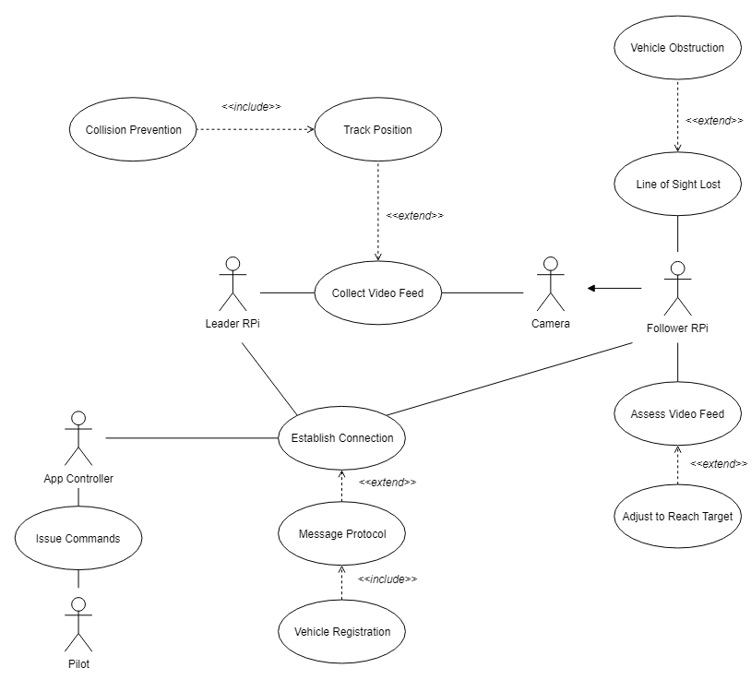

**4.3. Users Stories, Scenarios and Use Cases**

**User Stories:**

1. As a Pilot, I can register the Leader Vehicle.
2. As a Pilot, I can register the Follower Vehicle(s).
3. As the Leader Vehicle, I can lead the Follower Vehicle(s).
4. As a Follower Vehicle, I can follow the Leader Vehicle.
5. As the Remote Controlling Device, I can control the movement of the Leader Vehicle.
6. As a Pilot, I can use the Remote Controlling Device.
7. As a Follower Vehicle, I may lose Line of Sight to the Leader Vehicle.
8. As a Follower Vehicle, I can recognize an Obstruction Object.
9. As a Follower Vehicle, I can navigate around obstructions.
10. As a Follower Vehicle, I can notify the Leader Vehicle if they are no longer in Line of Sight.
11. As a Follower Vehicle, I can notify the pilot when there is loss of line-of-sight.
12. As a Follower Vehicle, I can reestablish Line of Sight with the Leader Vehicle.
13. As a Follower Vehicle, I can notify the Pilot when Line of Sight is regained.
14. As a Follower Vehicle, I can respond when the Leader Vehicle moves forward.
15. As a Follower Vehicle, I can respond when the Leader Vehicle moves backward.
16. As a Follower Vehicle, I can respond when the Leader Vehicle turns left.
17. As a Follower Vehicle, I can respond when the Leader Vehicle turns right.
18. As a Follower Vehicle, I can respond when the Leader Vehicle stops.
19. As the Leader Vehicle, I may lose connection with the Remote Controlling Device.
20. As the Leader Vehicle, I can notify the Pilot if I lose connection with the Remote Controlling Device.

**Scenarios:**

1. Jeff, a Pilot controls the Lead Vehicle to sharply turn down a hallway that causes the Follower Vehicle to lose Line of Sight with the Lead Vehicle. The Lead vehicle notifies the pilot that Line of Sight has been broken. The Follow Vehicle enacts its protocol to relocate the Lead Vehicle. When Line of Sight is reestablished, the Lead Vehicle notifies the pilot.
2. James is controlling the Lead Vehicle with the Following Vehicle behind when an obstructions falls between the vehicles. There is no line-of-sight loss, however, the following vehicle enacts a protocol that allows for the vehicle to search for a way around the obstruction and continue to follow the lead vehicle.
3. Jane is a soldier on the battlefield and she’s currently pinned down and unable to find a way to safety. She knows there’s a trap outside her position and has no way to avoid it without triggering it herself. She setups her remote controlled rc car and uses it to safely trigger the trap, allowing her to escape in one piece.
4. Jeremy wants to pilot the Lead Vehicle. Before he begins, he sets up the Lead Vehicle and Follower Vehicles one behind the other. He then enacts the Register Vehicle protocol to make sure all the Vehicles are connected and the Vehicle that is the Lead properly registers as the Lead, and the Followers are all properly registered to follow.
5. John wants to control the Lead Vehicle and have a Follower Vehicle trail it. John has already properly registered the vehicles. John takes the Remote Controlling Device and begins to navigate the Lead Vehicle as he wishes. The Follower Vehicle properly trails the Lead Vehicle.

**Detailed Use Cases:**

|  |  |
| --- | --- |
| Name | 1. Register Vehicle |
| Pre/Entry Condition | The Vehicle is on and broadcasting. |
| Trigger | The Pilot clicks “Register Vehicle” button. |
| Post/Exit-condition | A message of success is displayed in a pop-up and the vehicle information is added to the list and registered in the system. |
| Main flow of events -- identify all data elements | --The Pilot clicks the “Register Vehicle” button.  --A window is displayed listing broadcast IDs of vehicles.  --The Pilot selects the vehicle and clicks the “Add” button.  --The Pilot chooses whether vehicle is a Leader Vehicle or a Follower Vehicle.  --The Pilot clicks “Accept”. |
| Exceptions and alternate actions |  |
| Special requirements -- if any |  |

|  |  |
| --- | --- |
| Name | 2. Pilot Controls the Leader Vehicle |
| Pre/Entry Condition | The Leader Vehicle is registered. |
| Trigger | The Pilot inputs a command into the Remote Controlling Device. |
| Post/Exit-condition | The Leader Vehicle responds to the command. |
| Main flow of events -- identify all data elements | -- The Pilot inputs a command into the Remote Controlling Device.  -- The Remote Controlling Device sends a signal to the Leader Vehicle.  -- The Leader Vehicle responds to the command. |
| Exceptions and alternate actions |  |
| Special requirements -- if any |  |

|  |  |
| --- | --- |
| Name | 3. Follower Vehicle is Obstructed |
| Pre/Entry Condition | The Follower Vehicle is registered and has line of sight on Leader Vehicle |
| Trigger | The Follower Vehicle detects an Obstruction Object in its path. |
| Post/Exit-condition | The Follower Vehicle has navigated around the Obstruction Object. |
| Main flow of events -- identify all data elements | -- The Follower Vehicle is properly following behind the Leader Vehicle.  -- The Follower Vehicle identifies an Obstruction Object in its designated path.  -- The Follower Vehicle navigates around the Obstruction Object and continues on its path. |
| Exceptions and alternate actions | If the Leader Vehicle is out of the Line of Sight, the Follower Vehicle shall try to regain the Line of Sight with the Leader Vehicle. |
| Special requirements -- if any |  |

|  |  |
| --- | --- |
| Name | 4. Follower Vehicle follows Leader |
| Pre/Entry Condition | The Leader Vehicle and the Follower Vehicles are both registered. |
| Trigger | The Leader Vehicle moves away from the Follower Vehicle. |
| Post/Exit-condition | The Follower Vehicle is moving towards the Leader Vehicle. |
| Main flow of events -- identify all data elements | -- The Follower Vehicle detects that the Leader Vehicle is moving away from it.  -- The Follower Vehicle determines the direction that it must move in order to move towards the Leader Vehicle.  -- The Follower Vehicle moves towards the Leader Vehicle. |
| Exceptions and alternate actions |  |
| Special requirements -- if any |  |

|  |  |
| --- | --- |
| Name | 5. Follower Vehicle Loses Line of Sight |
| Pre/Entry Condition | The Follower Vehicle is following the Leader Vehicle. |
| Trigger | An Obstruction Object appears and the Follower Vehicle loses the Line of Sight of the Leader Vehicle. |
| Post/Exit-condition | The Follower Vehicle relocates the Leader Vehicle. |
| Main flow of events -- identify all data elements | -- The Follower Vehicle stops in place.  -- The Follower Vehicle shall try to regain line of sight with the Leader Vehicle.  -- The Follower Vehicle regains the Line of Sight with the Leader Vehicle. |
| Exceptions and alternate actions |  |
| Special requirements -- if any |  |

|  |  |
| --- | --- |
| Name | 6. Collision Prevention |
| Pre/Entry Condition | The Follower Vehicle approaches a certain proximity to the Leader Vehicle. |
| Trigger | The Follower Vehicle becomes too close to the Leader Vehicle. |
| Post/Exit-condition | The Follower Vehicle is no longer within a certain proximity to the Leader Vehicle. |
| Main flow of events -- identify all data elements | -- The Follower Vehicle becomes too close to the Leader Vehicle.  -- The Follower Vehicle stops in place.  -- The Follower Vehicle waits in place for the Leader Vehicle to move away.  -- The Follower Vehicle is no longer within a certain proximity to the Leader Vehicle. |
| Exceptions and alternate actions | -- The Follower Vehicle reverses if the Leader Vehicle advances towards the Follower Vehicle. |
| Special requirements -- if any |  |

|  |  |
| --- | --- |
| Name | 7. Connection Lost |
| Pre/Entry Condition | The Application is connected with the Leader Vehicle. |
| Trigger | The Application loses connection with the Leader Vehicle. |
| Post/Exit-condition | A Notification is sent to the Pilot that the connection was lost. |
| Main flow of events -- identify all data elements | -- The Application loses connection with the Leader Vehicle.  -- The Leader Vehicle stops in place.  -- A Notification is sent to the Pilot that connection to the Leader Vehicle is lost. |
| Exceptions and alternate actions |  |
| Special requirements -- if any |  |

|  |  |
| --- | --- |
| Name | 8. Search Mode |
| Pre/Entry Condition | The Application has lost connection to a Leader Vehicle or a Follower Vehicle. |
| Trigger | Search mode is triggered. |
| Post/Exit-condition | The Vehicle is reconnected. |
| Main flow of events -- identify all data elements | -- The Application has lost connection to a Leader Vehicle or a Follower Vehicle.  -- The Vehicle regains signal connection.  -- A Notification is sent to the Pilot. |
| Exceptions and alternate actions | -- The Application is unable to locate any vehicles. |
| Special requirements -- if any |  |

**4.4. System Sequence / Activity Diagrams**

**System Sequence Diagram:**

**a**

**Activity Diagram:**

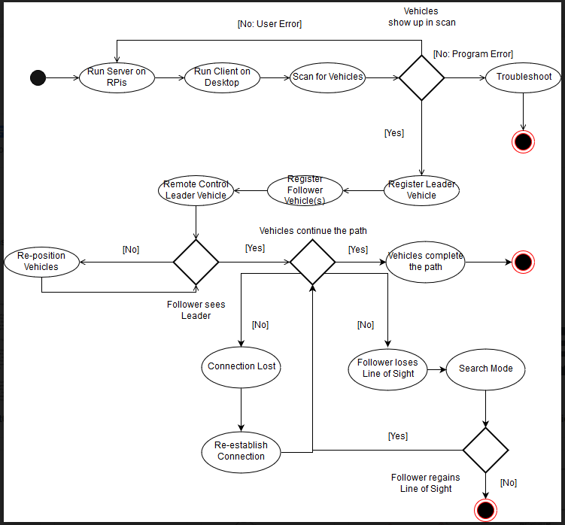

**5. User Interface Specifications**

**5.1. Preliminary Design**

a

**5.2. User Effort Estimation**

a

**6. Static Design**

**6.1. Class Model**

a

**6.2. System Operation Contracts**

a

**6.3. Mathematical Model**

QR Code Matrices

**6.4. Entity Relation**

1. Registration

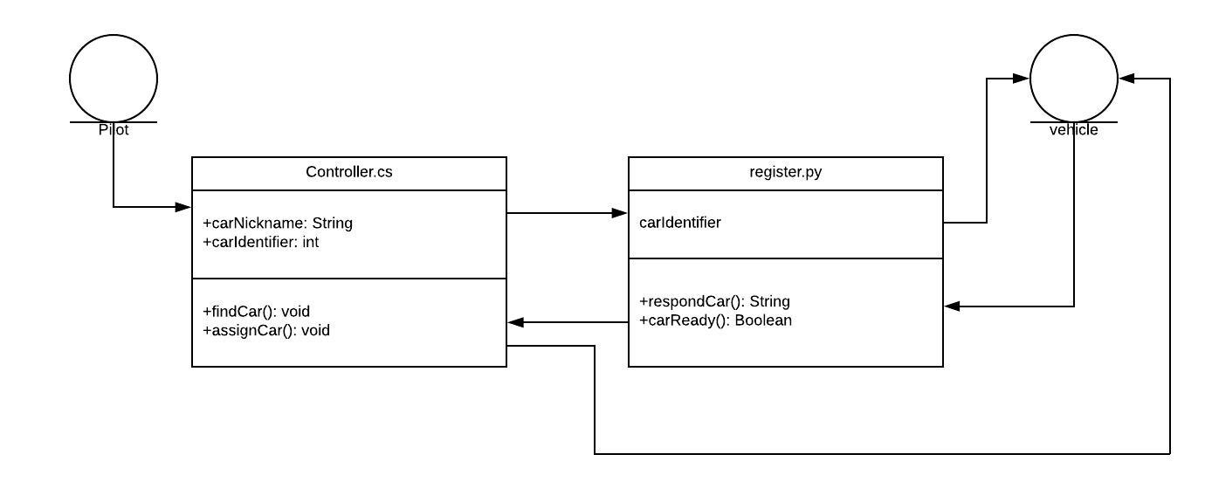

2 Leader Control.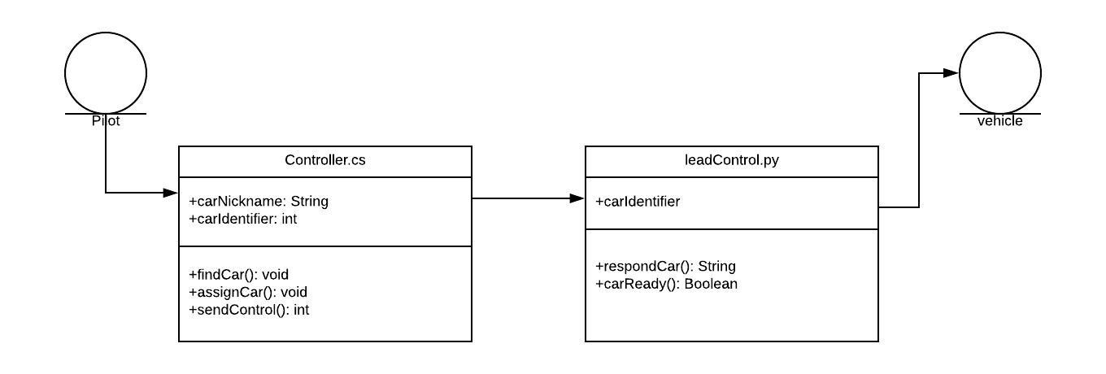

3. Follow the Leader  
  
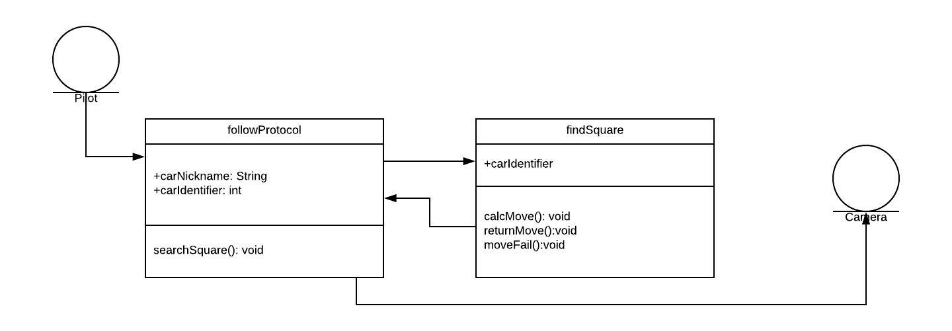

4. Line of sight Failure   
  
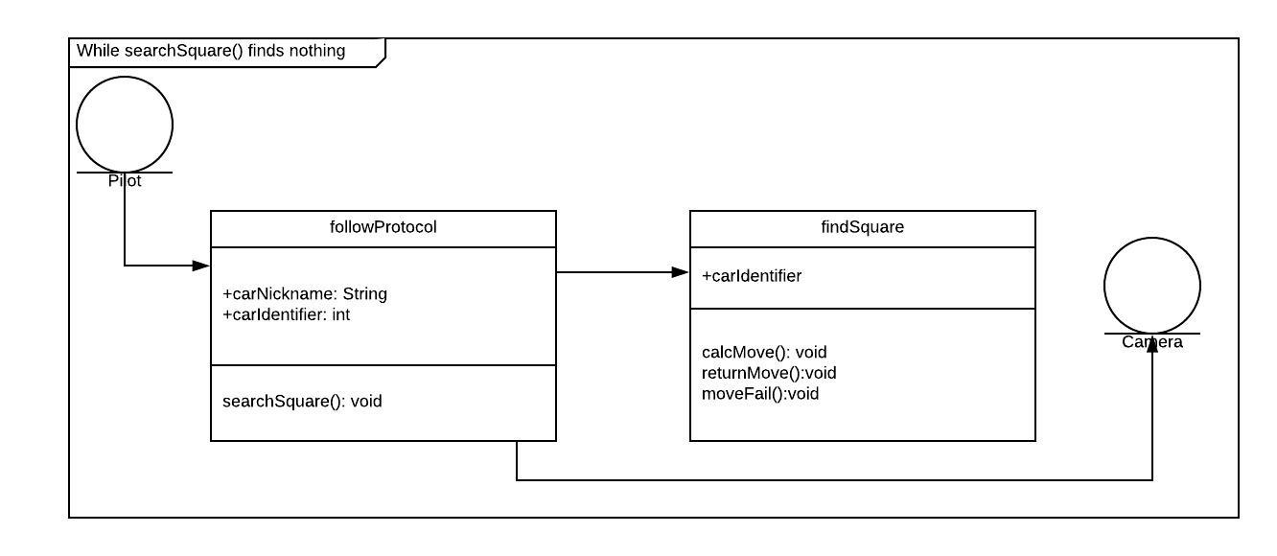

5. Collision Prevention  
  
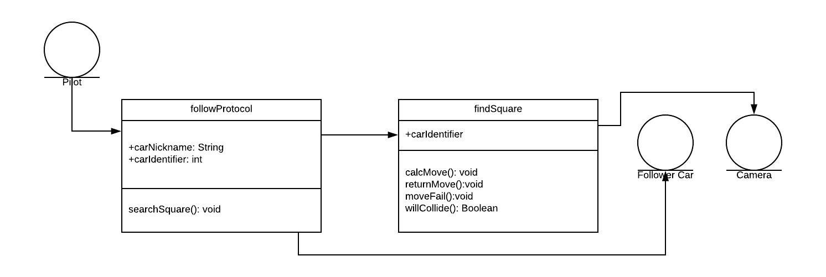

**7. Dynamic Design**

**7.1. Sequence Diagrams**

1. Registration

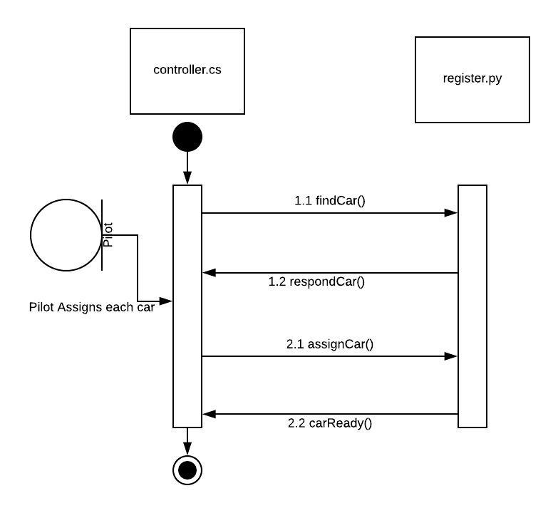

2 Leader Control.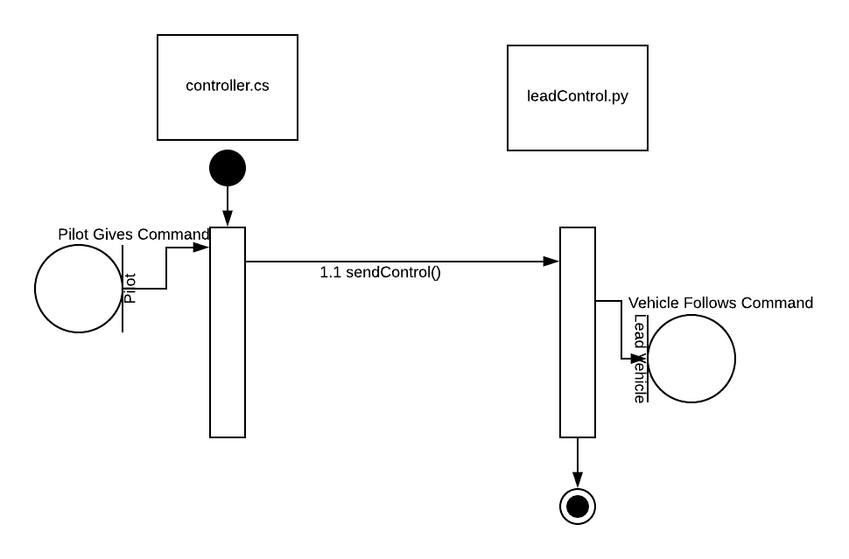

3. Follow the Leader  
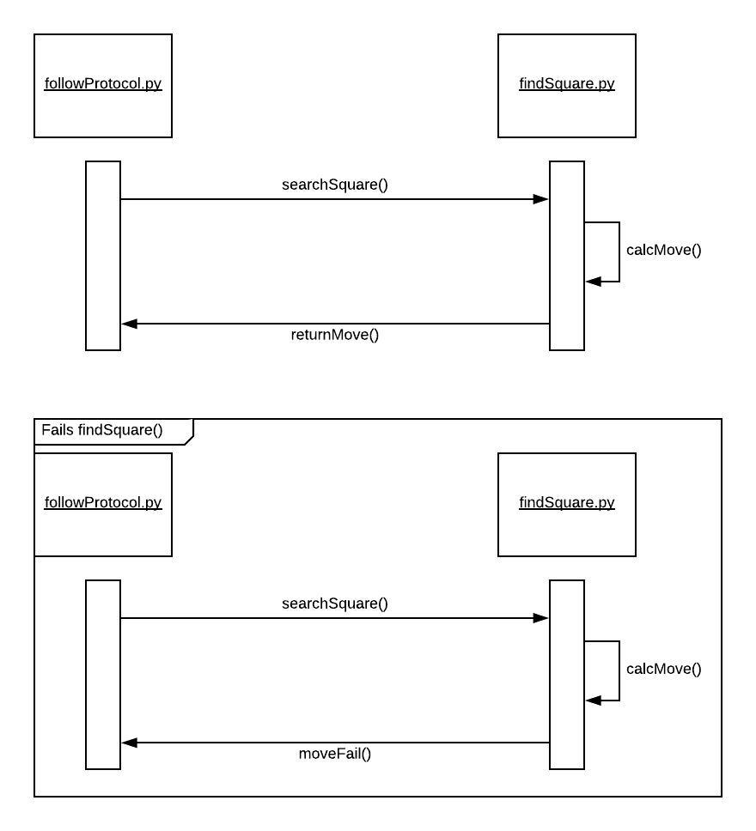

4. Line of sight Failure   
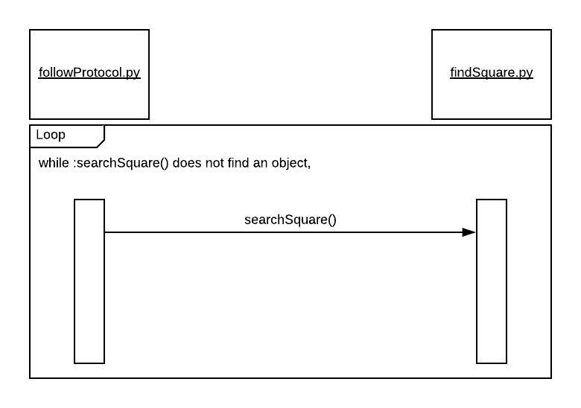

5. Collision Prevention  
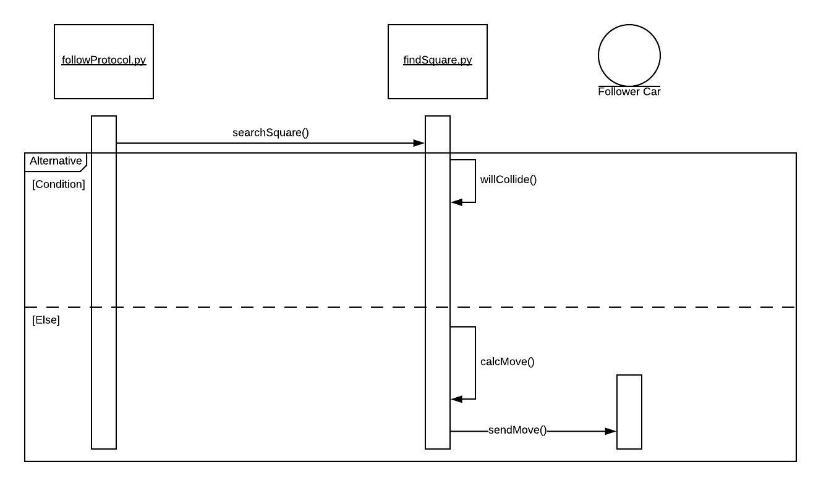

6. Network

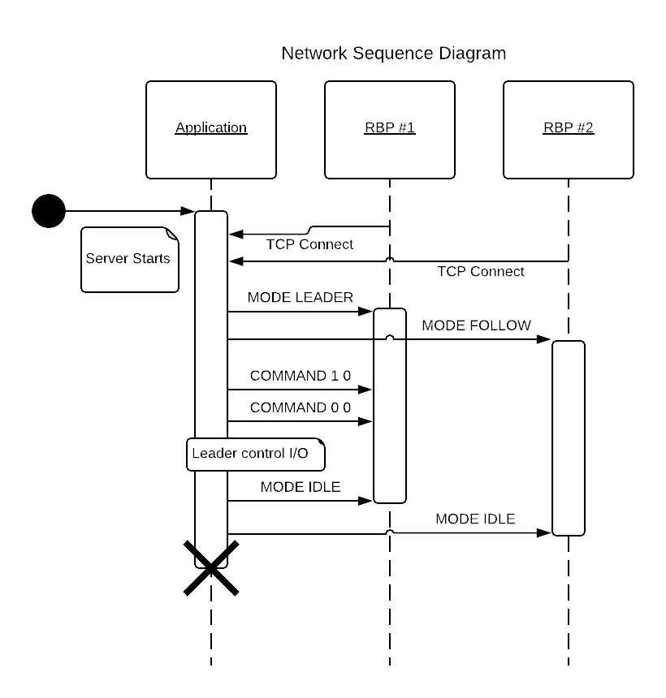

**7.2. Interface Specification**

a

**7.3. State Diagrams**

a

**8. System Architecture and System Design**

**8.1. Subsystems / Component / Design Pattern Identification**

a

**8.2. Mapping Subsystems to Hardware (Deployment Diagram)**

a

**8.3. Persistent Data Storage**

Local data storage / log files

**8.4. Network Protocol**

We needed to be able to send messages from the application to the robots in order to register them as either a leader or follower vehicle as well as controlling the leader vehicle. We decided on a messaging protocol where the application is client-based which connects to servers started on the Raspberry Pis. An example implementation in the Network Sequence Diagram, provided in Section 7.1.6. We decided not to use socket programming for our messaging protocol as we wanted a more sophisticated protocol. Instead, we turned to gRPC, an open-source Remote Procedure Call provided by Google. gRPC provides background network code and wrappers that can be called by our messaging protocol. It also provides functionality for several different programming languages which is useful for our team, since we are using mostly Python for our robots and C# for our application. Thus, for our messaging protocol, we ended up writing C# code for our client and Python code for our servers and made the calls to gRPC with its corresponding languages. We designed the protocol to be asynchronous. An example of how we use our network protocol with the project would be as such:

1. Turn on the Raspberry Pis and start the server (python PiCarDriver.py).
2. Start the desktop application to start the client.
3. Connect to the server through the client; The server gets a connection request.
4. Registering a Raspberry Pi as a Leader or Follower in the client sends a message to set the mode of the vehicle on the server.
5. Moving a Leader vehicle in the client sends a message to the server with direction and throttle as parameters; The vehicle moves with the provided direction and throttle.

**8.5. Global Control Flow**

a

**8.6. Hardware Requirement**

* 2 or more Raspberry Pis (version 3 or better)
* Raspberry Pi Power Source for each Pi
* Micro USB w/ Pre-loaded Linux OS Configuration Files for each Pi
* HDMI cable for initial network configuration
* 2 or more of the Sunfounder Smart Video Car Kit V2.0 / PiCar-V, each including:
  + Robot HATS
  + PCA9685 PWM Driver
  + TB6612 Motor Driver
  + 2x18650 Battery Holder
  + 2x DC Gear Motor
  + 3x Sunfounder SF0180 Servo
  + 120 degree Wide-angle USB Camera
  + 4x Wheels
  + USB Wi-Fi Adapter (optional)
  + Misc building & wiring material
* 4 Rechargeable UM-18650 3.7v Batteries (+2 for each additional PiCars)
* Desktop Computer able to run

**9. Algorithms and Data Structures**

**9.1. Algorithms**

a

**9.2. Data Structures**

a

**10. User Interface Design and Implementation**

**10.1. User Interface Design**

a

**10.2. User Interface Implementation**

a

**11. Testing**

**11.1. Unit Test Architecture and Strategy/Framework**

a

**11.2. Unit Test Definition / Test Data Selection**

a

**11.3. System Test Specification**

a

**11.4. Test Reports per Spring**

a

**12. References**

a